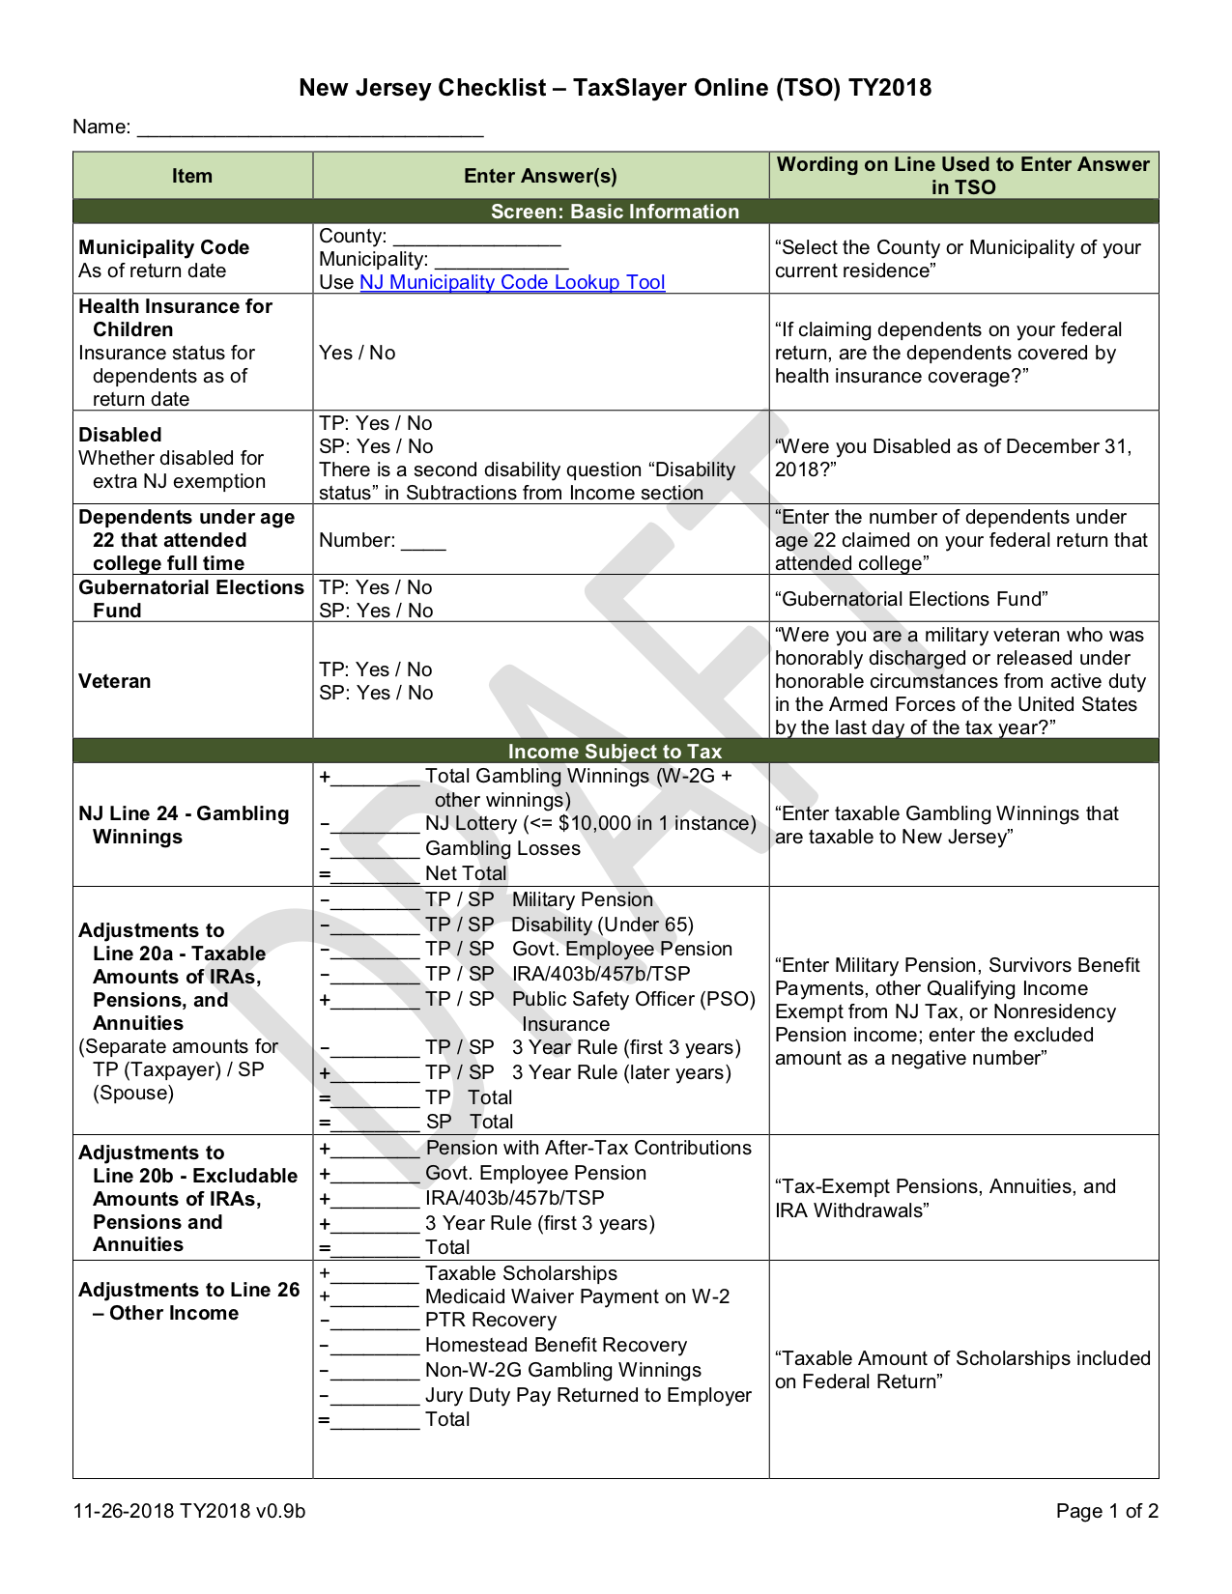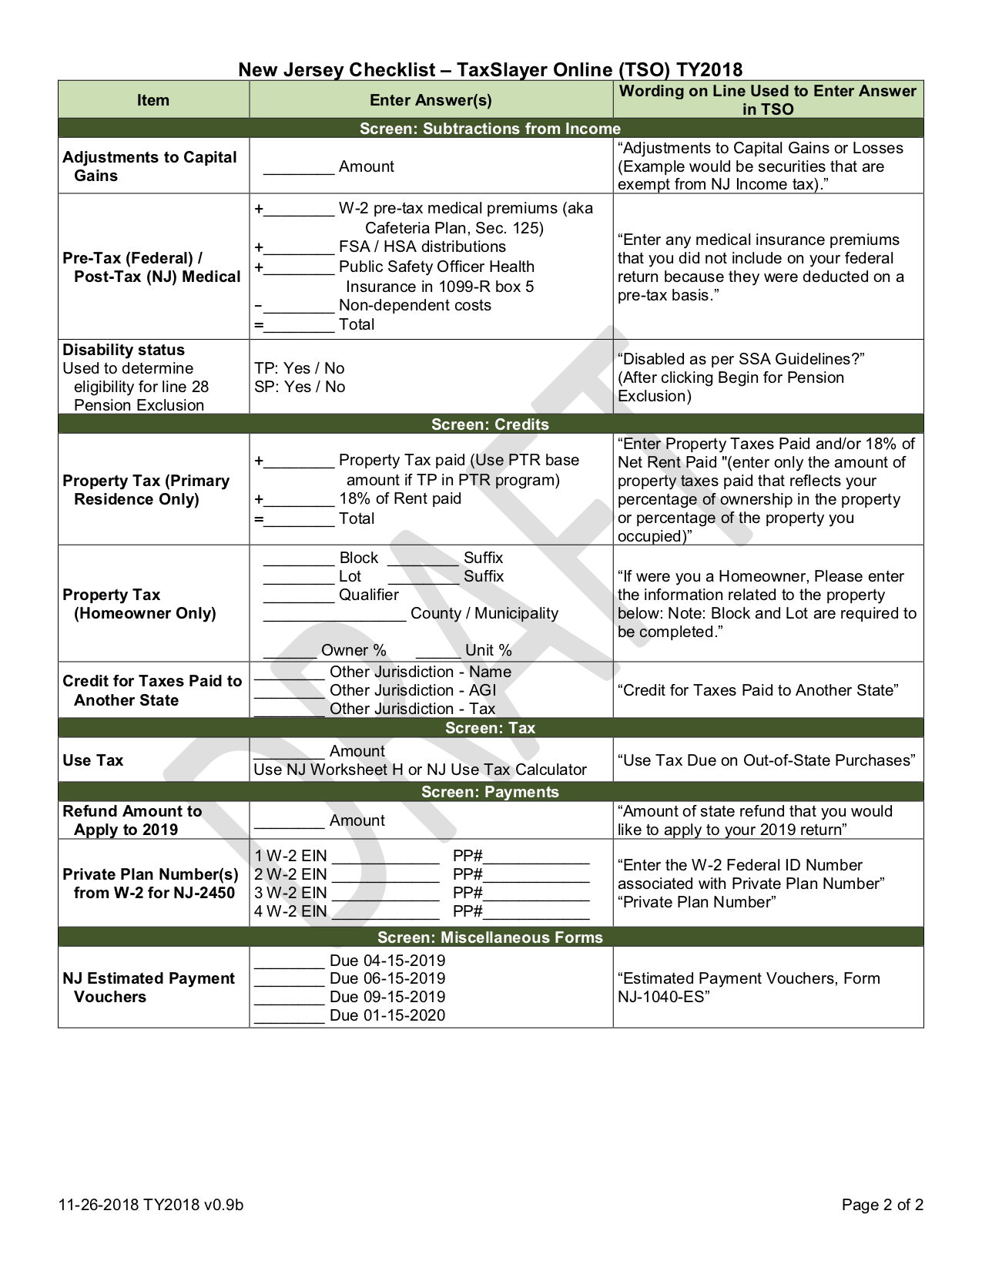

-5,400

5,400

Lynch NJ Checklist v0.9a

0

Lynch

Somerset

Bedminster Township

1,677

1,677

Lynch NJ Checklist v0.9a